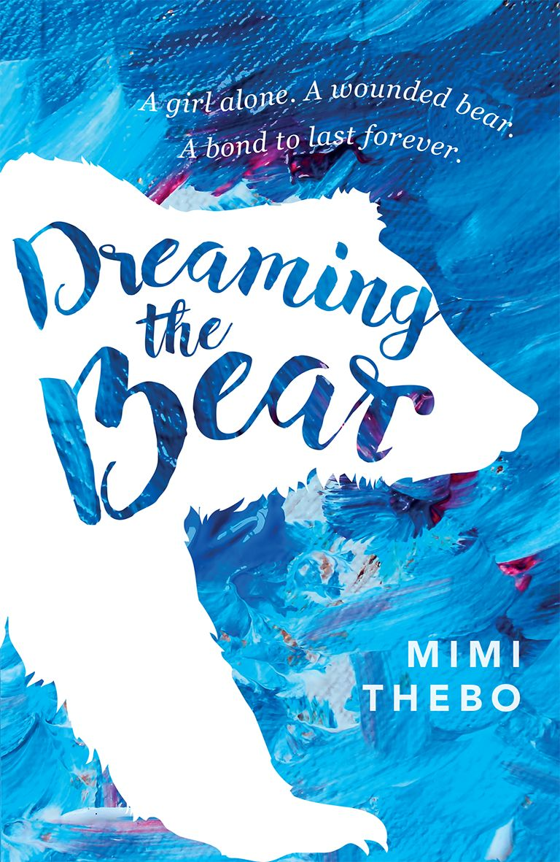

"When I get up, there's nobody home. Even Mum has gone out. The note says, 'I have to check my emails. I'll snowmobile to the meltline and be back soon. XX
Mummy'.
And I think, 'Good. I can feed my bear...'"

